To write a procedure to run the virtual machine of different configuration and to check how many virtual machines can be utilized at a particular time.

Step1: To run the virtual machine of different configurations.

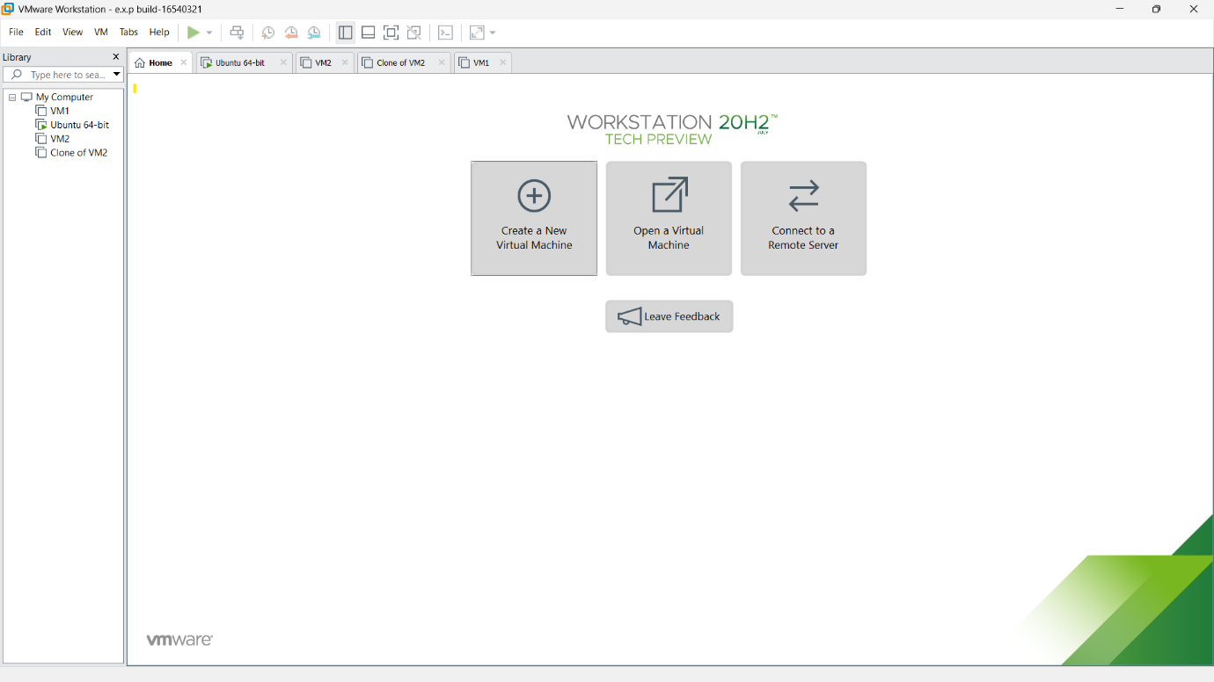

Step2: Then below shown message will be displayed and click next.

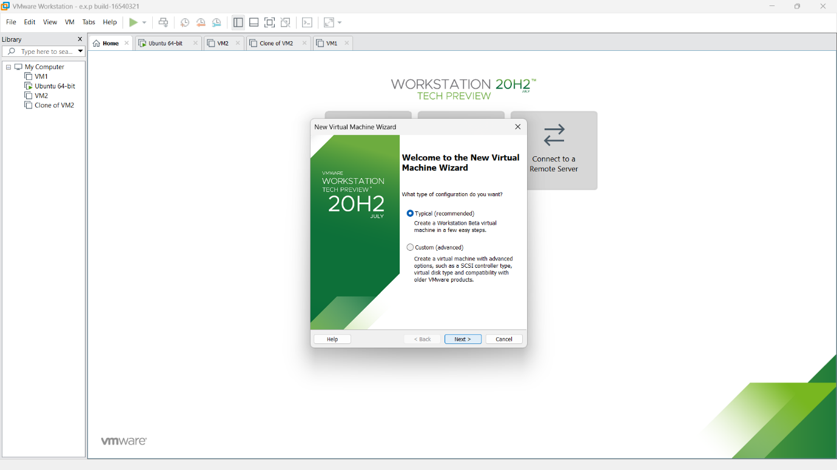

Step3: Here,we are going to Create a Virtual Machine with 1 CPU, 2GB RAM and 15GB storage disk using a Type 2 Virtualization Software. So need of any installer.just click the third option and next.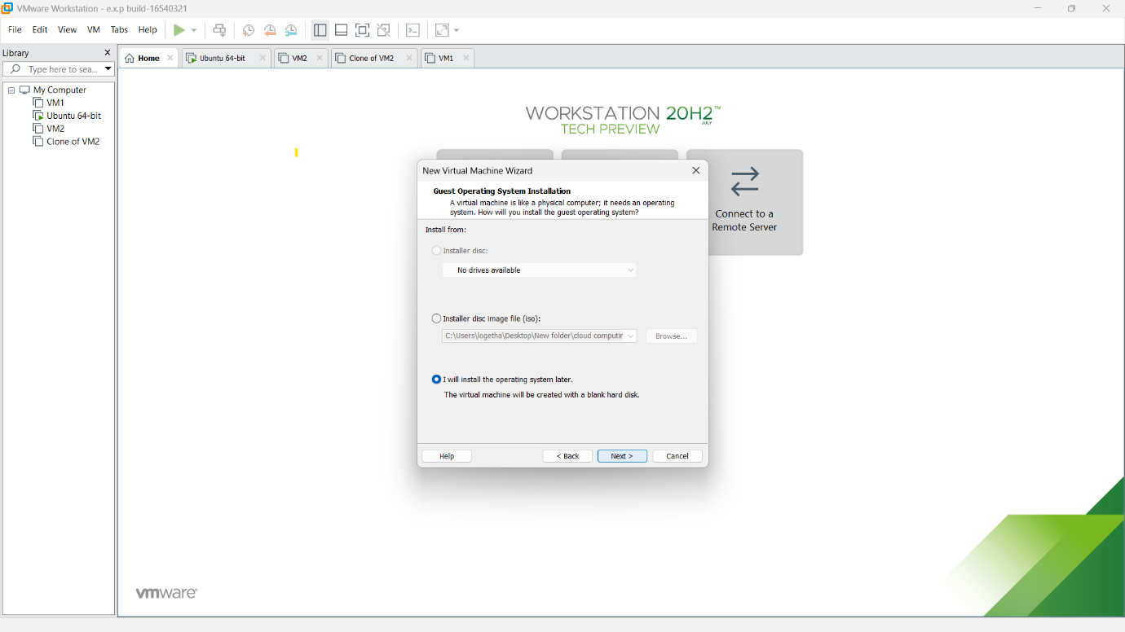

Step4: Then select any type of os.

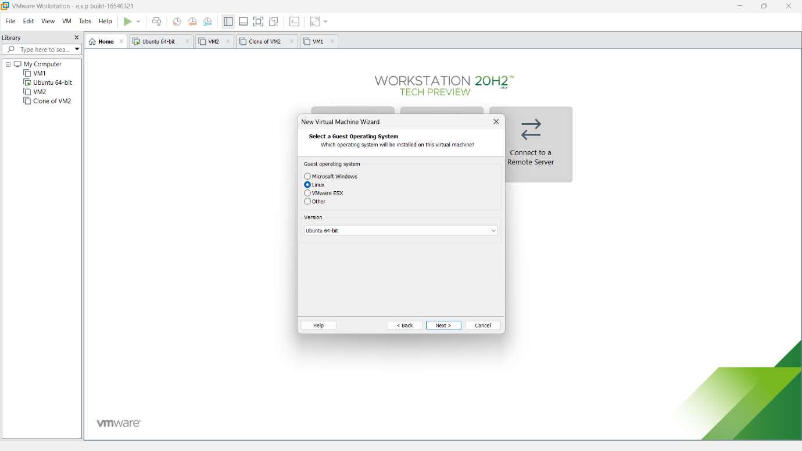

Step5: then provide appropriate name for our virtual machine.

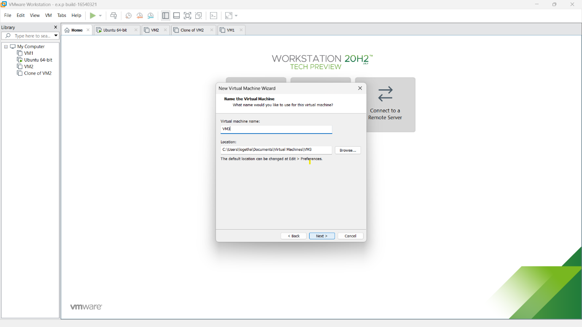

Step6: then provide appropriate hard disk size.

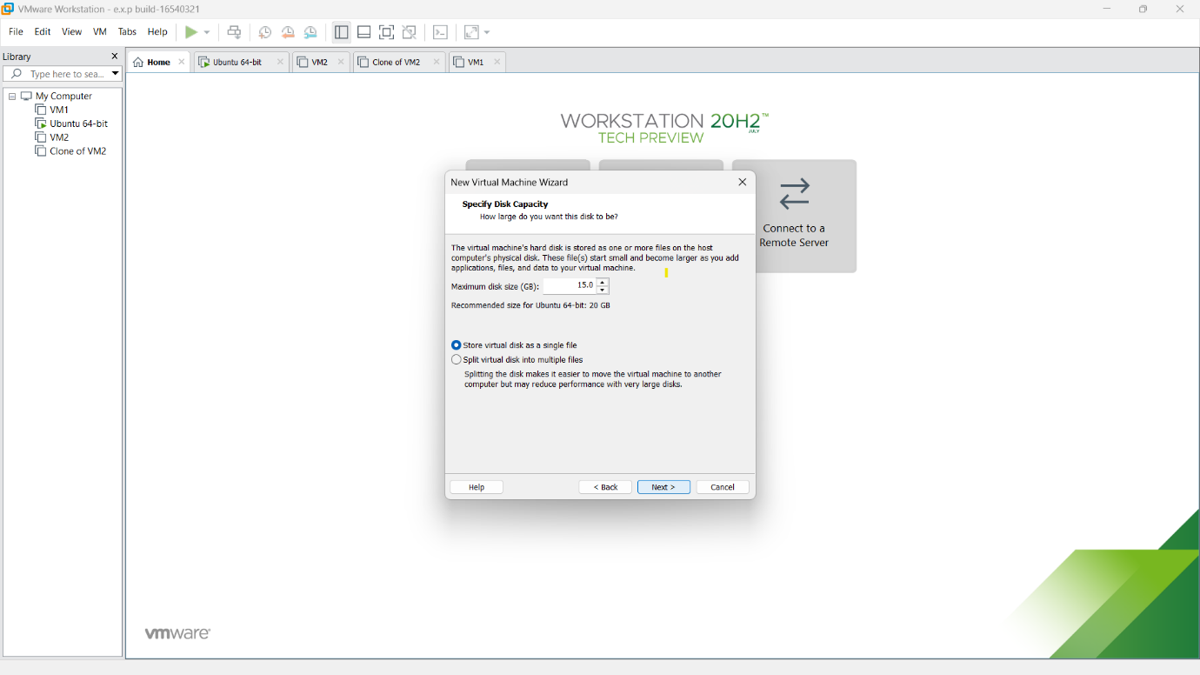

Step7: Then verify all the given details are correct and if any changes ,correct it with the customize hardware option.

